How to add an Include File

What is an include file?
Include files are like header files in C programming. They are use to insert any legitimate SPICE code into a simulation. You can include entire SPICE netlists, simulation stimuli, or spice models. The possibilities are endless.

The syntax for an include file is:
.INC “<filename>”

With this line the contents of the file “filename” are inserted into the SPICE deck

How to actually add an include file

From the main menu: PSPICE->New Simulation Profile
(or edit simulation profile if you already have one)

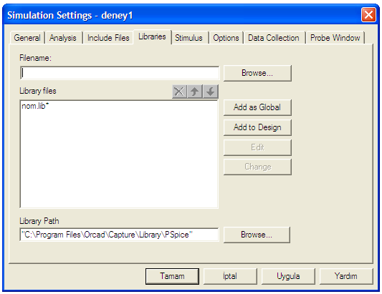

- On the menu above Tab to Libraries
- You will see the menu below
- Browse for the file that contains your models (ex. EEM311.lib)

IMPORTANT
When you browse to add EEM311.lib have it display all files or you will not see it. It defaults to showing only files ending with .inc

- Hit <Add as Global>

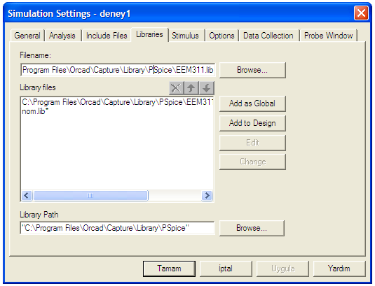

How to add an library

- From the main menu: Place->Part
- Hit <Add New library>
- Browse to find the correct .olb file ex EEM311.olb – then add

